Lab 1: Oracle DDL and User Administration
Date: 19/09/2025

Objectives
- Create parent and child table relationships.
- Verify the tables created.
- Create and manage non-privileged users.

Tools
- Oracle Database XE
- SQL Developer
- Docker
Lab Users:
- SYS (Admin user)
- sandesh_csit (Lab user)

Steps

1. Access Docker Container
Open terminal and enter the Oracle container:
docker exec -it advanced_dbms bash

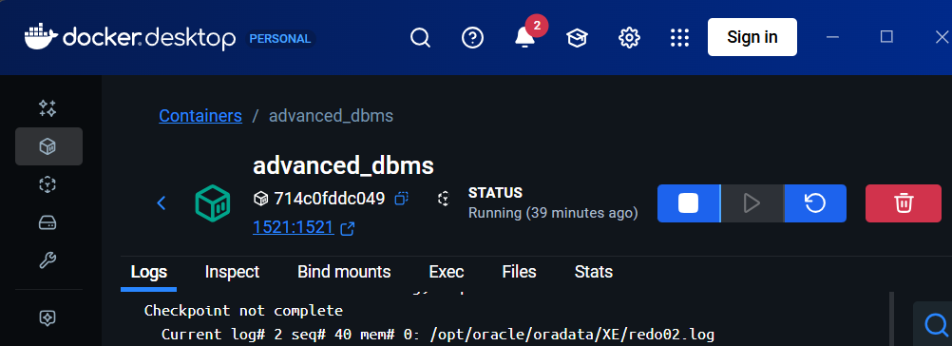

2. Connect as SYSDBA
Connect to Oracle using SQL*Plus as SYSDBA:
sqlplus sys/oracle@XE as sysdba

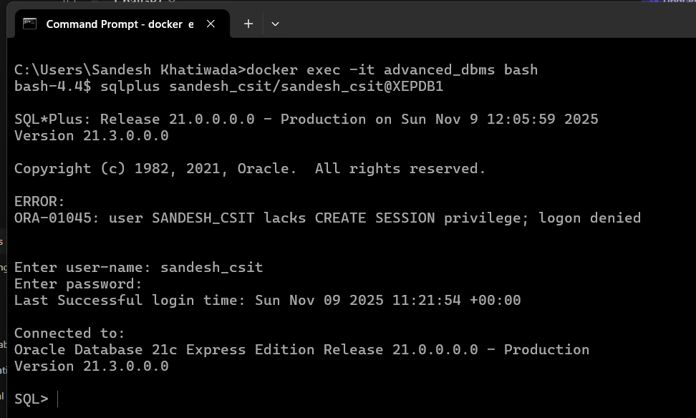

3. Switch to the Pluggable Database
ALTER SESSION SET CONTAINER = XEPDB1;
SHOW CON_NAME;
-- Should display: XEPDB1

SHOW PDBS;
-- Should display:
-- PDB$SEED
-- XEPDB1
-- FREEPDB1

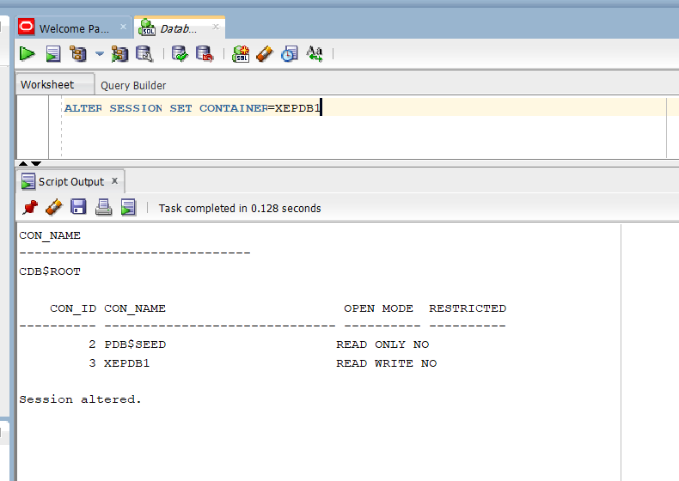

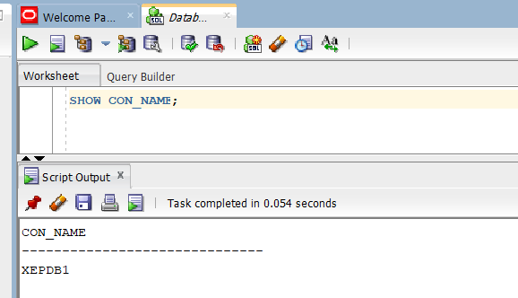

4. Create Lab User
Create a new user sandesh_csit with password sandesh_csit:
CREATE USER sandesh_csit IDENTIFIED BY sandesh_csit ACCOUNT UNLOCK;
Grant necessary privileges:
GRANT CONNECT, RESOURCE, DBA TO sandesh_csit;

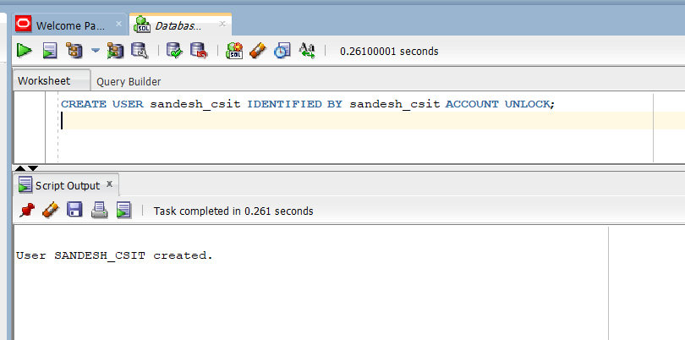

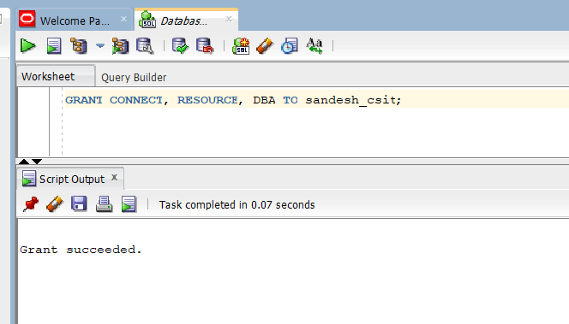

5. Connect as Lab User
Open a new session as sandesh_csit:
sqlplus sandesh_csit/sandesh_csit@XEPDB1
SHOW USER;
You should see:
USER is "SANDESH_CSIT"
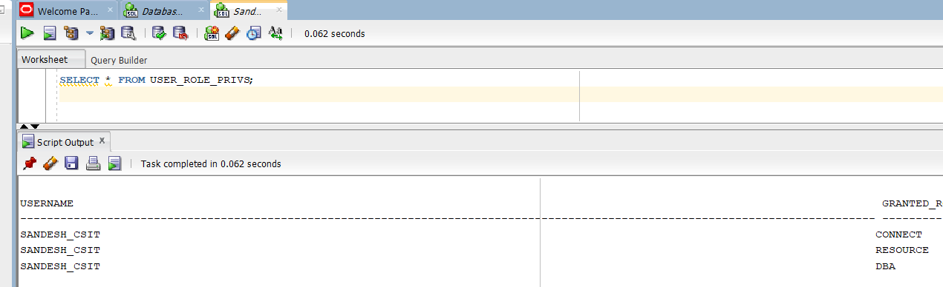

6. Create Parent and Child Tables
Parent Table: COURSES
CREATE TABLE courses (
course_id NUMBER PRIMARY KEY,
course_name VARCHAR2(50) NOT NULL,
instructor VARCHAR2(50)
);
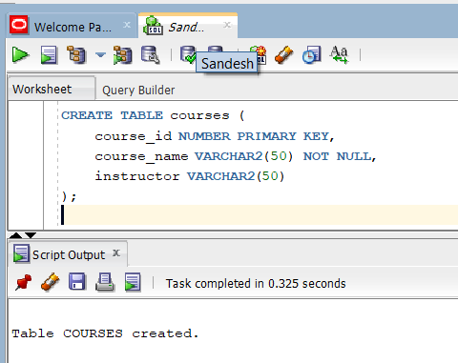

Child Table: STUDENTS
CREATE TABLE students (
student_id NUMBER PRIMARY KEY,
first_name VARCHAR2(30),
last_name VARCHAR2(30),
course_id NUMBER,
CONSTRAINT fk_course
FOREIGN KEY (course_id)
REFERENCES courses(course_id)
);
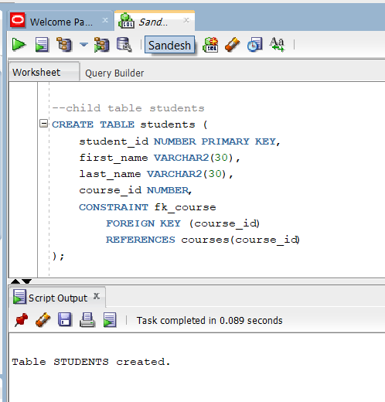

7. Modify Tables (ALTER) and Delete Tables
Alter Parent Table: Add a new column credits to courses
ALTER TABLE courses
ADD credits NUMBER(2);
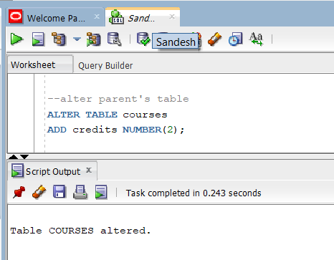
Alter Child Table: Add a new column email to students
ALTER TABLE students
ADD email VARCHAR2(50);
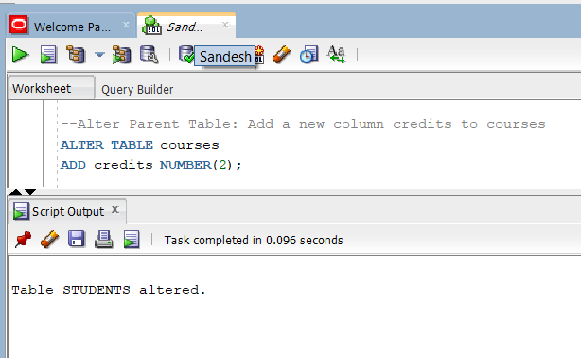
Modify Column Type: Change email length
ALTER TABLE students
MODIFY email VARCHAR2(100);
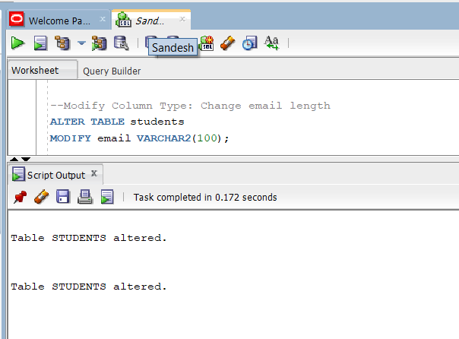
Drop Column: Remove email column if not needed
ALTER TABLE students
DROP COLUMN email;
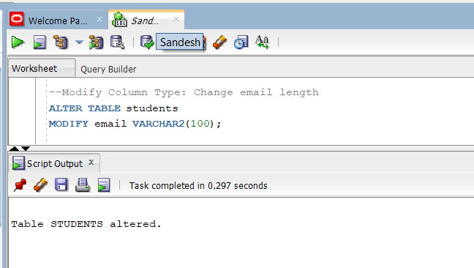
Delete (Drop) Tables:
DROP TABLE students;
DROP TABLE courses;
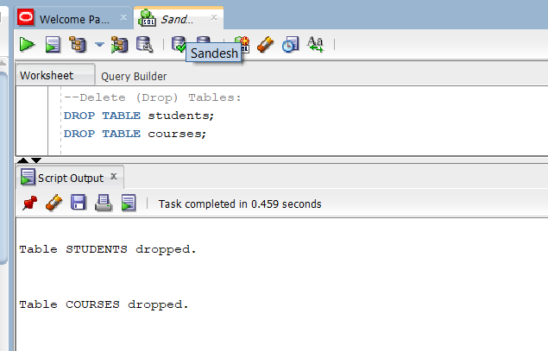

Conclusion
In this lab, we have successfully:
- Created a non-privileged user (sandesh_csit) with appropriate privileges.
- Created parent (courses) and child (students) tables with a foreign key relationship.
- Practiced altering tables: adding columns, modifying column types, and dropping columns.
- Practiced deleting tables using DROP TABLE.
- Reinforced basic DDL commands (CREATE, ALTER, DROP) and user administration.

